Update from Mozambique
I will start with the good news that the building of the new school at Chimoio is going really well and a few weeks ago l know that it was above the first level of windows. I am not actually sure how big it will be as l have not seen any of the drawings, but it is a miracle, with the humanitarian crisis there, that this project continues to move forward apace.
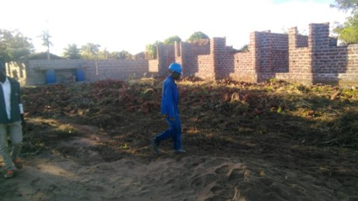
More good news was that Bishop Manuel, as pictured here with Reverend Albertina and other helpers, planted 104 trees near the school on World Environment Day. The tree seen here being planted by the bishop was a gift to him from Addis Ababa!
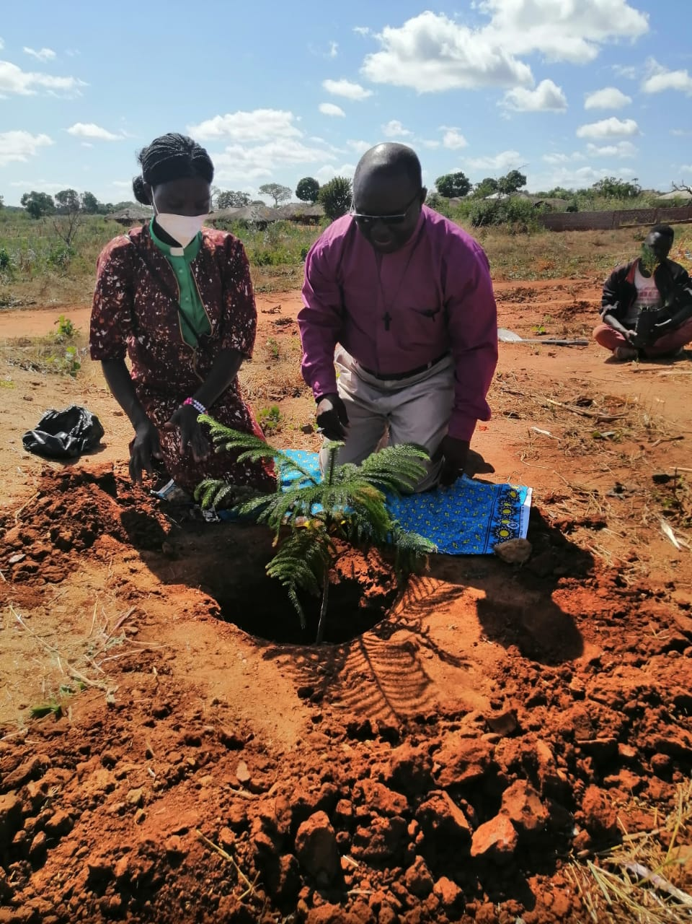
However, other news is not so good, with the insurgency, lack of food security, and poor access to health resources and education. Even Coronavirus, which is currently in its third wave locally, cannot be given priority, despite so many people living in camps. The situation remains pretty desperate.
Following the insurgent attack in Palma in March, by the end of May, 54,824 people had fled from Palma alone. Around 20,000 more are still stuck in the area around the Total Gas Project with very little access to food, shelter and medicines. I heard that Total had now closed down their gas project which was very much behind the troubles, so there is a (small) hope that the insurgents will be encouraged to leave the area. A lot of those who have fled, and continue to flee, have arrived in Pemba, where our link church is, or Montepuez. Overall the number of Internally Displaced Persons (IDPs) is estimated at 700,000.
In Pemba, many refugees are being hosted by local families, in a heart-warming response to this crisis, with those families being supported with additional food parcels. In addition, locally, all 28 communities who are hosting IDP's have also created a demonstration farm as part of the recovery plan for these displaced people.
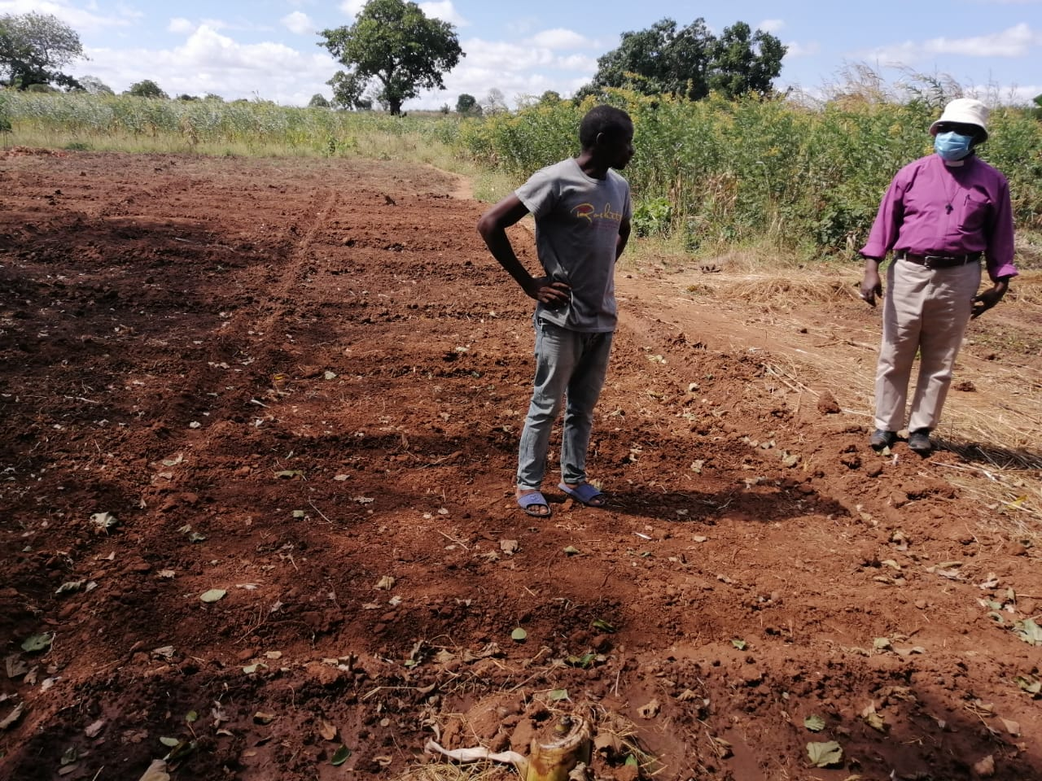
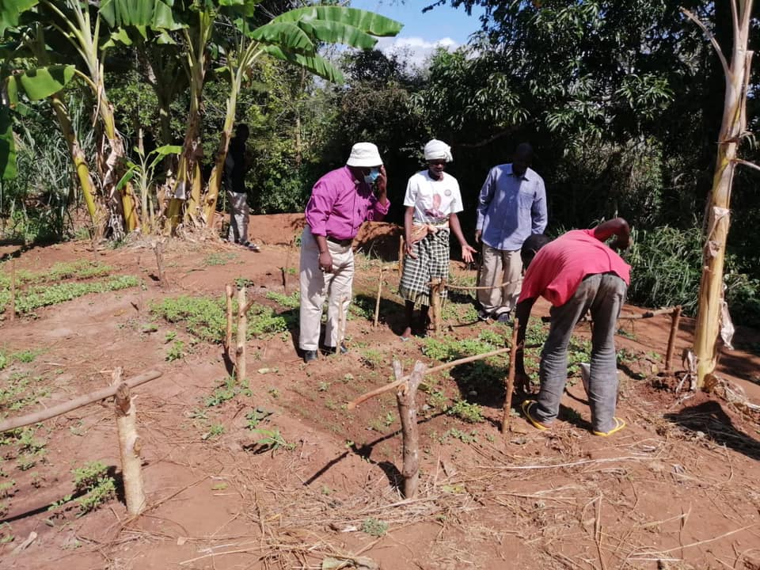
This map below from OCHA (United Nations) gives an idea of the numbers of IDPs and the dangerous areas (dark blue) where the fighting and attacks on civilians continue, and how close it all is to Pemba, at the bottom.
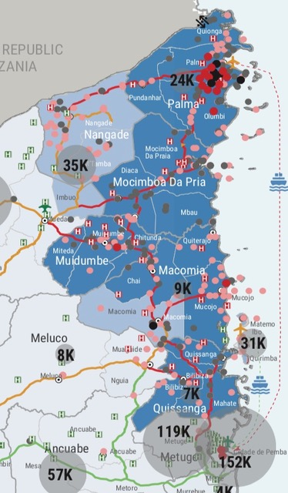
The diocese is responding, and is doing well in partnership with various aid agencies. This picture shows Muassite, who visited us in 2019, working on the frontline assessing IDPs who had arrived by boat, in a desperate state. This poor lady had actually given birth on that boat, having tragically lost all of the rest of her family.
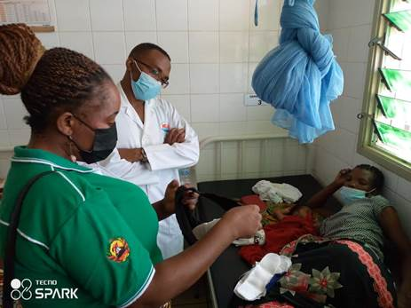
We sent all £8310 of the money you raised for our Lent Appeal 2021 to MANNA, to help with this crisis, and we hope you can see how keenly the money is needed and how it is directly being used to help on the ground. MANNA, and others, have supported emergency food parcels for IDP households containing rice, beans, oil, soap, water purifying tablets, etc. The Diocese is at present working to create a larger umbrella plan that all the partners can continue to contribute to, which will include more emergency work and some trauma response work with the IDP's (77% of them are women and children) and some agricultural recovery work.
We pray for Bishop Manuel and all his team.

Suzie Gordon

To find out more about MANNA, and to donate: https://manna-anglican.org/
Also, this website is excellent for updates from the various agencies involved: https://reliefweb.int/country/moz
Here is a lovely video from Bishop Manuel in April when he visited an IDP camp:
https://www.facebook.com/MANNAANGLICAN/posts/3816432661745486
and a video of Muassite's personal inspiring response back in March:
https://www.facebook.com/MANNAANGLICAN/posts/3707781692610584

